



Computer Communications 27 (2004) 13–26

www.elsevier.com/locate/comcom

Abstract

Dynamic bandwidth allocation in multi-class
connection-oriented networks

Samer Taha*^{,1}, Mohsen Kavehrad

Electrical Engineering Department, The Pennsylvania State University, University Park, State College, PA 16802, USA
Received 2 August 2002; revised 17 April 2003; accepted 30 April 2003

Multi-class network is becoming a more attractive solution to provide Quality-of-Service guarantee, as more quality-demanding
applications are emerging. This research considers networks that provide connection-oriented services, as in ATM and MPLS technologies,
for example. A common scheme for Dynamic Bandwidth Allocation (DBA) in connection-oriented communications is to dynamically
segregate bandwidth between different trafﬁc categories. These categories can represent topological Virtual Paths or different Classes-of-
Service with different Quality-of-Service requirements. Bandwidth segregation can be efﬁcient if and only if demands for different Classes-
of-Service or different Virtual Paths can be predicted accurately. This led us to develop a novel algorithm that has a much wider vision in
allocating resources than classical distributed algorithms. We call the proposed algorithm, Virtual Demand Distribution (VDD) algorithm.
This algorithm utilizes signaling packets to broadcast information that enhances the performance of DBA algorithms. Mathematical analysis
of multi-class connection-oriented networks and performance analysis/comparisons of the proposed VDD algorithm and a Simple
Distributed algorithm are presented.
q 2003 Elsevier B.V. All rights reserved.
Keywords: Dynamic bandwidth allocation; Quality-of-Service; Multi-class Network

1. Introduction

Dynamic Bandwidth Allocation (DBA) for networks
carrying multi-class trafﬁc has been investigated within
different contexts. We are concerned with architectures that
work on the call level. Most of the work at this level was
directed to dynamically allocate bandwidth to different
Virtual Paths (VPs). The VP concept is a basic characteristic
of ATM and ISDN networks, which provide connection-
oriented services. VPs can be designed based on topological
optimization. Also, bandwidth can be segregated between
different CoSs with different QoS requirements, as in Ref. [1].
Bandwidth segregation is an effective way of managing
resources to serve different CoSs of trafﬁc with different
QoS requirements. However, as was shown in Ref. [2],
allocating bandwidth to VPs may lead to a lower efﬁciency
(throughput) if bandwidth is not carefully (optimally)
allocated. We point out that the basic reason for

* Corresponding author. Tel.: ю 1-503-613-0270; fax: ю 1-503-613-6494.
E-mail address: samer.m.taha@intel.com (S. Taha).
1 Current address: Mail Stop RA3-250, LTD Automation—Ronler Acres
3, Intel Corporation, Oregon, USA.
0140-3664/03/$ - see front matter q 2003 Elsevier B.V. All rights reserved.
doi:10.1016/S0140-3664(03)00145-2

non-optimal allocation of bandwidth is the difﬁculty and
inaccuracy in predicting demands for different CoSs. One of
the essential reasons for this inaccuracy is the nature of most
DBA algorithms, which are absolutely distributed.
Much work has been done recently on trafﬁc engineering
over MPLS architectures Ref. [3]. However, most of the
efforts were directed to dynamically distribute load on
alternative paths in order to efﬁciently utilize resources
while achieving the best possible (QoS), like the work in
Refs. [4,5]. Although CoSs were also supported in these
studies, little efforts were directed to optimize the allocation
of bandwidth among CoSs in a common link.
We believe DBA, trafﬁc engineering, and routing are
related tasks and cannot optimally perform without
cooperation with each other. Routing and load distribution
on alternative paths—Label Switched Paths (LSPs) in
MPLS context—can be viewed as a necessary process on
small time scales to efﬁciently utilize scattered resources.
This process takes place at the edge of an MPLS network
(ingress nodes). But at the same time, there can be
competition on bandwidth between different LSPs, which
may represent different CoSs, at each link in the network,

14

S. Taha, M. Kavehrad / Computer Communications 27 (2004) 13–26

both at the core and at the edge of an MPLS network. As the
aggregated demand for different CoSs/LSPs varies slowly
over time, a DBA process is necessary to optimally
distribute bandwidth between competing CoSs/LSPs based
on a speciﬁc objective function. This objective function
usually takes into consideration user-utilities and revenues,
which are functions of QoS, pricing model, and regulations
governing different CoSs. From here on, we will use the
concept of CoSs to refer to both LSPs and classes of
different levels of QoS in any connection-oriented multi-
class network.
In the context of connection-oriented services, usually
objective functions can be designed at higher levels, like
controlling the blocking rates of calls. We can assume that a
lower level control will take the responsibility of computing
the required bandwidth by each call, based on the CoS of
that call, the QoS speciﬁcations of that CoS, and the
optimization criteria deﬁned for that CoS. This computed
bandwidth is usually called ‘effective bandwidth’ Ref. [6].
So, these low level controls may, for example, minimize the
average delay of sessions within a speciﬁc CoS or minimize
the average packet loss rate for sessions within another CoS,
and so on. On the other hand, a higher-level control is
needed to allocate (segregate) bandwidth between the CoSs
in an optimal way. We recommend that these two levels of
control be carried at different layers, this would achieve two
objectives: ﬁrst, routing stability; since this dynamic
segregation of bandwidth would usually be a slow process
and thus QoS routing algorithms can have valid and
meaningful information about the status of the network.
Second, controlling call blocking rates of different CoSs
would become a possible task. Controlling the call blocking
rates is expected to be an important issue, especially when
advanced pricing systems will be introduced Ref. [7].
When we consider different DBA algorithms, we can
classify them to centralized and decentralized algorithms.
Centralized algorithms provide a single point of failure and
require huge amounts of information, which is, usually,
broadcasted using ﬂooding protocols. Also, their ability to
provide a solution for a large-scale network with varying
demands in an appropriate time is questionable. On the other
hand, decentralized algorithms are implementable, but
cannot provide an optimal solution because they don’t
have a global vision of the network.
The major contribution of this paper is that we propose
and evaluate a novel algorithm that performs a slow DBA to
allocate bandwidth globally over all backbone links of a
multi-class connection-oriented network. We call this
proposed algorithm Virtual Demand Distribution (VDD)
algorithm. The VDD algorithm is a distributed algorithm
that can approach global optimality. The VDD collects more
information than classical distributed algorithms, but the
amount of collected information is still small, compared
with the amount of information that any centralized
algorithm needs in order to achieve global optimality.
This extra information is obtained by utilizing the signaling

messages used for establishing new connections in any
multi-class network providing connection-oriented services.
Also, to provide stability for routing algorithms we avoid
using rapid DBA (on a per-session level) control. Instead,
our slow DBA system deals with aggregates of trafﬁc and
responds to variations in demands on a relatively slow basis.
The word ‘relatively’ here means with respect to the speed
of updating routing tables.
We approach the development of this algorithm
throughout two stages of analysis. In the ﬁrst stage, we
analyze the dynamics of DBA implemented in a single link,
assuming stationary trafﬁc with variable-size calls and
known statistics. In this stage, we demonstrate the effect of
transient responses on predicting blocking rates of calls
when a Complete Partitioning (CP) schema is used and we
develop an algorithm for optimal resource allocation by
extending the recursive algorithm proposed in page 25 of
Ref. [8]. In the second stage, we analyze a multi-link multi-
class connection-oriented loss network and emphasize the
difﬁculty in accurately predicting demands in such an
environment. In this stage we develop a framework for
analyzing demands and call blocking rates of non-stationary
trafﬁc in a multi-link network and then we develop a novel
algorithm to accurately predict demands for different CoSs
in a multi-link multi-class loss network. These accurately
predicted demands could then be used to allocate resources
based on the algorithm that was developed in the ﬁrst stage.
The algorithms developed in these two stages combined
together form the proposed VDD algorithm. To evaluate the
performance of the proposed VDD algorithm we used
Bones Designer, a sophisticated simulation tool, and built a
multi-node network with a conﬁguration shown in Fig. 1.
We built this simulation to emulate an as real a network as
possible, with 48 h of non-stationary varying trafﬁc
generated at each node. A detailed description of this
simulation is provided in Section 5. In addition to VDD
algorithm, we simulated performance of an equivalent
Simple Distributed (SD) algorithm, applied to two CoSs. As
we mentioned above, in Section 2 we start by analyzing
DBA algorithms and call blocking rates in a single
communication link.

2. Single-link analysis

When different trafﬁc categories or classes share a
common link, three possible resource-sharing techniques
can be considered. These are Complete Sharing (CS),
Virtual Partitioning (VPT), and Complete Partitioning (CP).
In CS, no control over the performance of different CoSs
can be exercised. However, it is the simplest possible
technique and works well under light loads. But, a well-
designed network should not be lightly loaded all the time.
In CP, a strict control over the performance of any CoS can
be exercised, but wastage of resources is an issue to worry
about. Under high load conditions, CP works very well if

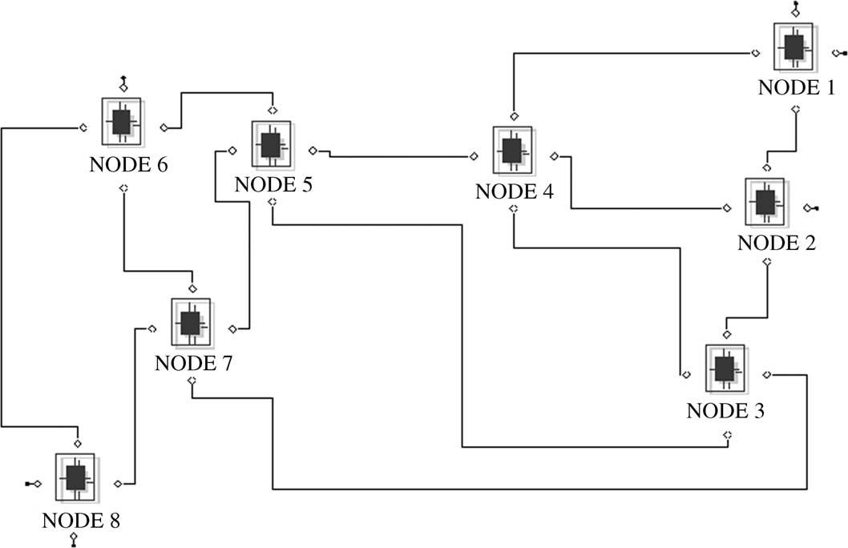

S. Taha, M. Kavehrad / Computer Communications 27 (2004) 13–26

Fig. 1. The conﬁguration of the network used in simulating the VDD and other algorithms, (simulation tool: Bones Designer).

15

and only if demands on different CoSs can be estimated
accurately. VPT can be considered as a mixture of both CS
and CP techniques. Resources are not wasted under VPT
technique, but because of the possible sharing of resources
by different CoSs and because performance depends on
allocated capacities to different CoSs, no strict control over
the blocking rates of different CoSs can be achieved,
especially when the trafﬁc is non-stationary. Trunk-
Reservation DBA is an example of a VPT scheme.
In this paper, we are interested in a highly-utilized
backbone network supporting different CoSs which are
sensitive to call blocking rates. Because of the differences in
these CoSs due to differentiation in treating different
sessions of these CoSs at the packet level, or because
some CoSs may represent VPs with different geographical
signiﬁcance, a differentiation between the blocking rates of
these CoSs is desired. Thus, we will adopt a CP scheme,
where capacities will be dynamically allocated in a non-
stationary trafﬁc environment. To approach the analysis of
call blocking rates estimates in a multi-link multi-class
network carrying non-stationary trafﬁc and adopting a DBA
under a CP scheme, we start in Section 2.1 by analyzing the
call blocking rates in a single-link with one CoS carrying
stationary trafﬁc, then we will continue building on the
results of this subsection in the rest of the paper.

requests with known distribution. Such systems are known
as stochastic Knapsack systems. In Appendix A, we review
several formulas and algorithms developed so far with
different model assumptions, and we show that there is no
closed-form formula for predicting call blocking rates in such
systems, neither in an exact nor in an approximate form.
Thus, we found that the following recursive algorithm is the
best to build upon for deriving a DBA algorithm with the
objective of controlling the call blocking rates of different
CoSs. This algorithm assumes a model where there is a
limited number of bandwidth sizes, such that a size-k session
requests b_{k}units of bandwidth with a probability of P_{b}рb_{k}Ю;
r_{k}ј l_{k}=m_{k}; l_{k}is the mean arrival rate of size-k calls, m²k¹is
the mean holding time of size-k calls, M is the number of
different bandwidth sizes, and C is the capacity of the link
which equals multiples of units of bandwidth. The expected
call blocking rate of size-k calls (B_{k}) can be found as follows:

Algorithm 1.

Set g(0) ј 1, g( j) ј 0 for j , 0.
For h ј 1,2,…,C
{
X

2.1. Call-blocking probability for one CoS of stationary
trafﬁc with variable size bandwidth requests

We consider here predicting the call blocking rate
gрhЮ ј р1=hЮ

}
Set
X

kј1
рb_{k}Юr_{k}gрh 2 b_{k}Ю:
р1Ю

experienced by calls with stationary Poisson arrival process,
stationary exponential holding time, and variable-size
G ј

hј0
gрhЮ:
р2Ю

16

For h ј 0,1,…,C
{

S. Taha, M. Kavehrad / Computer Communications 27 (2004) 13–26

say from v_{k}to v⁰k;while no new calls are accepted. This is a
death process, thus:

qрhЮ ј gрhЮ=G:

}
р3Ю

z_{k}ј
X_{k}

mјv⁰
k
1
mS_{k}

seconds;

р6Ю

B_{k}ј
X

hјC2b_{k}ю1

qрhЮ:

р4Ю
where the expression in Eq. (6) can be approximated as
follows:
рv_{k}2 v⁰k^{Ю}

In Section 2.2, we use Algorithm 1 to derive an algorithm
that allocates bandwidth between CoSs of non-stationary
z_{k}<
S_{k}рv_{k}ю v⁰k^{Ю}=2
seconds:
р7Ю

trafﬁc sharing a common link with the objective of
controlling the ratios between call blocking rates of different
CoSs. For simplicity, and without loss of generality, we
consider two CoSs.

2.2. Controlling call-blocking probabilities for two CoSs of
non-stationary trafﬁc with variable size bandwidth requests

Our objective is to dynamically allocate bandwidth
between two CoSs, such that the ratio of class-2 blocking
rate рB²p^{Ю}to class-1 blocking rate рB¹p^{Ю}is b, over the decision
interval t_{d}. A class-1 call requests a bandwidth b¹m with
probability P¹b^{р}b¹m^{Ю}; a class-2 call requests a bandwidth b²n
with probability P²b^{р}b²n^{Ю}: Class-1 mean arrival rate is A₁
calls/s and class-2 mean arrival rate is A₂calls/s. Class-1
The approximation in Eq. (7) is accurate as long as рv_{k}2
v⁰k^{Ю}=v⁰k^{p}1; which is the case in a realistic backbone
network, especially as long as the assumption in Eq. (5) is
true. Note, v⁰k is determined by the capacity allocation
decision for class-k.
However, in our case, sessions utilizing class-k require
different amounts of bandwidth. Thus, based on the
available information to the system, v_{k}and v⁰k can be
approximated as the utilization and the allocated capacity,
respectively, divided by the average size of the bandwidth
requests. Let Q₁be the allocated capacity (bps) to class-1,
(W_{t}2 Q₁) is the allocated capacity (bps) to class-2. Let u_{k}
be the utilization (bps) of class-k just before calculating a
new bandwidth allocation decision. We can deﬁne the
following approximations for the length of the transient
period:
рu₁=b¹2 Q₁=b¹Ю р

mean holding time is S²1¹s, class-2 mean holding time is
S²2¹: We also deﬁne b¹: the average bandwidth size of class-
1 calls, b²: the average bandwidth size of class-2 calls,
l¹m^{ј}P¹b^{р}b¹m^{Ю}A₁; l²k^{ј}P²b^{р}b²n^{Ю}A₂calls/s, m¹m^{ј}S₁; ;m; and
m²n^{ј}S₂; ;n, m ј 1; 2; …; M₁and n ј 1; 2; …; M₂; where
M₁is the number of possible bandwidth sizes at class-1 and
z₁<

z₂<
рS₁Юрu₁=b¹ю Q₁=b¹Ю=2^{U}u₁2 Q₁Ю seconds;
рu₂=b²2 ЅW_{t}2 Q₁=b²Ю
рS₂Юрu₂=b²ю ЅW_{t}2 Q₁=b²Ю=2
Ј Uрu₂2 ЅW_{t}2 Q₁Ю seconds:
р8Ю

р9Ю

M₂is the number of possible bandwidth sizes at class-2. In
general, we assume non-stationary stochastic process where
the mean arrival rate of class-k is A_{k}рtЮ; t is time. However,
the holding time is assumed to be a stationary process with
constant mean value (1/S_{k}) seconds. We assume that
Based on the assumption in Eq. (5), and assuming that A₁
and A₂can be accurately estimated every t_{d}seconds, an
algorithm (Algorithm 2) for bandwidth allocation between
the two CoSs can be developed by incorporating the
transient effects in Eqs. (8) and (9), and by extending
Algorithm 1. The objective of Algorithm 2 is stated in

›A_{k}рtЮ
›t
< 0:0 for t₀# t # t₀ю t_{d};
р5Ю
Eq. (10).
Every t_{d}seconds, ﬁnd Q₁such that:

thus the system is assumed to be under stationary trafﬁc
throughout the decision interval t_{d}.
An important phenomenon arises here, at each decision
instance a situation where the allocated capacity is less than
the utilization of class-k may occur for a duration of time

Number of class 2 2 blocked calls throughout t_{d}seconds
Number of class 2 1 blocked calls throughout t_{d}seconds

ј b:
р10Ю

equals to z_{k}seconds, where z_{k}is the time for class-k
utilization to drop below the newly allocated capacity. This
is because we assume that the system cannot drop any active
session, in order to maintain QoS parameters promised to
users. During this time interval (z_{k}) all class-k arriving calls
will be blocked. Expected value of z_{k}рz_{k}Ю can be exactly
found if all calls utilizing class-k require the same amount of
bandwidth. In this case, the problem becomes ﬁnding the
expected time for the number of class-k active calls to drop,
Note, in Algorithm 2, all bandwidth quantities must be
integer numbers, the allocation decision is updated every t_{d}
seconds, Q₁рnЮ is the nth allocation decision.

Algorithm 2.

Estimate A₁and A₂.
Measure u₁and u₂.

Set Q⁰1^{ј}Q₁рn 2 1Ю
While (ldl . e)
{

S. Taha, M. Kavehrad / Computer Communications 27 (2004) 13–26

}
If f , b
{

17

Set g₁р0Ю ј 1; g₂р0Ю ј 1; g₁рjЮ ј 0 for j , 0, g₂рjЮ ј 0
for j , 0.
For h ј 1; 2; …; Q⁰1
{
Q⁰1^{ј}Q⁰1^{ю}1:
}
d ј f 2 b.
}

X₁

1

1
!
Q₁рnЮ ј Q⁰1

g₁рhЮ ј р1=hЮ

}

kј1
рb¹k^{Ю}P_{b}рb_{k}ЮA₁
S₁
g₁рh 2 b¹k^{Ю}: р11Ю
For understanding Eqs. (11 – 14), reader is advised to
refer to Ref. [8]. Eqs. (17) and (18), deﬁne the average
blocking rates for the two CoSs. The second summation

For h ј 1; 2; …; ЅW_{t}2 Q⁰1
{
X₂2

2

!
ﬁnds the probability of blocking a speciﬁc size request and
the ﬁrst summation ﬁnds the average probability of blocking
any-size request. In Eq. (19), the effect of the transient

g₂рhЮ ј р1=hЮ

}
Set
X | 0  1

kј1
рb¹k^{Ю}P
b^{р}b_{k}ЮA₁
S₂
g₂рh 2 b²k^{Ю}р12Ю
periods, approximated in Eq. (8) and (9), is included. Class-
k blocking probability found in Eqs. (17) and (18) is
meaningful after the end of the transient period, if it exists.
Nominator in Eq. (19) divides the expected number of
blocked class-2 calls throughout the decision period (t_{d}) by
the number of all calls expected throughout the same period.

G₁ј

Set

hј0
g₁рhЮ:
р13Ю
Denominator of Eq. (19) does the same, but for class-1.
Note also, in Eq. (19), the values of z₁and z₂belong to one
the following three cases, рz₁ј 0; z₂ј 0Ю; рz₁ј 0; z₂. 0Ю;
or рz₁. 0; z₂ј 0Ю: It is clear that the inclusion of the

G₂ј
ЅWXQ⁰1
hј0
g₂рhЮ:
р14Ю
transient response in the calculations of the DBA equations
will work as a slowing tool. It will slow down the changes in
the allocated bandwidth if a sudden and large change occurs

For h ј 0; 1; …; Q⁰1
{
in the demands. This is desirable, since by this, the network
will not make dramatic changes in the allocations unless
new demands pattern are long-lived. e is a parameter that

q₁рhЮ ј g₁рhЮ=G₁:

}
For h ј 0; 1; …; ЅW_{t}2 Q⁰1
{
q₂рhЮ ј g₂рhЮ=G₂:

}
X₁X⁰1
B¹p^{ј}P¹b^{р}b¹k^{Ю}
kј1 hјQ⁰1
1²b_{k}ю1
X₂ЅWXQ⁰1
B²p^{ј}P²b^{р}b²k^{Ю}
kј1 hјQ⁰2

q₁рhЮ:

q₂рhЮ:
р15Ю

р16Ю

р17Ю

р18Ю
deﬁnes the desired accuracy in forcing the differentiation
ratio b.
In this paper, we try to emphasize the importance of
accurate predictions of demands. We show, by utilizing the
above algorithm, that estimating average arrival rates of two
CoSs based on local information is not efﬁcient, even if
networks have simple structures. To overcome this problem,
which is a serious one in CP schemes, we propose a novel
algorithm that utilizes signaling messages in connection-
oriented networks with reservations to approach global
optimality in predicting demands at each router/switch.

3. Loss network analysis

In this section, we provide a loss network analysis for a

f ј
1²b_{k}ю1
рA₂B²p^{р}t_{d}2 z₂Ю ю A₂z₂Ю=A₂t_{d}
A₁B¹p^{р}t_{d}2 z₁Ю ю A₁z₁=A₁t_{d}

;
multi-class network, for simplicity and without loss of
generality we will restrict the analysis to two CoSs.
However, this analysis can be extended to any number of
CoSs.

рz₁from Eq: р8Ю and z₂from Eq: р9ЮЮ

If (f . b
{
Q⁰1^{ј}Q⁰1²1:
р19Ю

Let set N be the set of all nodes in a network that supports
two connection-oriented CoSs.
Let i; j [ N; where i – j.
Let l^{ij}be the output port connecting node i to j.

18

S. Taha, M. Kavehrad / Computer Communications 27 (2004) 13–26

A ﬂow is deﬁned as a sequence of output ports visited by complicated forms of dependency among decisions com-

the trafﬁc of one or more sessions carrying information
between two nodes. f_{v}ij;n is the nth ﬂow moving through l^{ij}
and belongs to class v, v ј 1, 2. Two trafﬁcs connecting the
same two nodes, but each one moving through different
intermediate nodes are considered as two different ﬂows.
aрf_{v}ij;n^{Ю}is the average arrival rate of calls forming the ﬂow
f_{v}ij;n;the arrival process is assumed to be Poisson. For each l^{ij}
we deﬁne a tree T_{v}ij;which is a set that contains all f_{v}ij;n;
n ј 1; 2; …; s^{ij}v;where s^{ij}v is the total number of ﬂows at l^{ij}
that belong to class v. Any ﬂow that belongs to class v and
passes through l^{ij}is a member of T_{v}ij:For every tree T_{v}ij;we
deﬁne roots R^{ij}v and branches B^{ij}v:R^{ij}v is a set that contains r^{ij}v;n;
n ј 1; 2; …; s^{ij}v where r_{v}ij;n is the part of f_{v}ij;n that starts at the
source of f_{v}ij;n and ends at node i. B^{ij}v is a set that contains b^{ij}v;n;
n ј 1; 2; …; s^{ij}v where b^{ij}v;n is the part of fv^{ij};n that starts at
a node j and ends at the destination of f_{v}ij;n:We deﬁne T¹рT_{v}ij_{Ю}
which is a group of trees. A tree T_{v}xy[T¹рT_{v}ij_{Ю}if and only if
there exists at least one ﬂow f_{v}ij;n [ T_{v}ij such that l^{xy}[ f_{v}ij;n:
We call the group T¹рT_{v}ij_{Ю}the group of son-trees (ﬁrst
generation trees) of T_{v}ij:Similarly, T²рT_{v}ij_{Ю}is the group of
grandson-trees (second generation trees) of T_{v}ij:A tree
T_{v}ab[T²рT_{v}ij_{Ю}if and only if there exists at least one ﬂow
f_{v}ij;n [ T_{v}ij such that l^{xy}[ f_{v}ij;n and there exists at least one
ﬂow f_{v}xy;k[T_{v}xy such that l^{ab}[ f_{v}xy;k:In a similar way, we can
deﬁne T^{z}рT_{v}ij_{Ю}; where z can take any value between 0 and 1.
Note that T⁰рT_{v}ij_{Ю ј}{T_{v}ij}:
Claim 1. There exists a bandwidth allocation algorithm
that can perform as optimal as a centralized algorithm in
a multi-class connection-oriented network while working
in a distributed way and requiring an amount of
information much less than the global demand matrix.

A detailed proof for the above claim is documented in
Appendix B. So far, we claim the existence of an algorithm
that runs in a distributed way but still can approach global
optimality by collecting an amount of information much
less than the global demand matrix. We believe VDD is a
very strong candidate to be such an algorithm.
In a practical environment, the demand of any ﬂow is not
known a priori. Demands can be measured, and based on
measured demands over an averaging window of Dt starting
at time t₀; demands can be predicted throughout рt₀ю
Dt; t₀ю 2DtЮ: The accuracy of this prediction depends on the
nature/correlation of the variation in demands and on Dt. As
Dt increases, above a certain value, the correlation between
successive intervals decreases. On the other hand, as Dt
decreases below a certain value, there will not be enough time
to estimate the average arrival rate of calls and hence estimate
the demand. In Ref. [9], it was shown that the variations in
aggregated demands are usually slow enough such that a
decision interval of 1 h would even be faster than necessary.
Measuring demand needs time and so does broadcasting
information. In addition to timing considerations, there are
puted at different output ports throughout the whole multi-
class network. With all these considerations, and based on
previous discussions, we developed the VDD algorithm. In
the Section 4, we explain and state the VDD algorithm.

4. The virtual demand distribution (VDD) algorithm

Let t_{d}be the decision interval.
Let t_{u}be the update interval.
T_{d}ј mt_{u}; where m $ (maximum number of hops),
this is a necessary condition.

The following requirements are necessary for any
network for it to be able to support the VDD algorithm:

1. Signaling packets (call-setup packets) must be used to
establish any new connection.
2. Packets belonging to a speciﬁc session have to follow the
same path that was assigned initially by the network.
3. Acknowledgments have to follow the same path—in the
reverse direction—that was followed by the call-setup
packets. Acknowledgments have to keep all the infor-
mation collected by the call-setup packets.
4. Call-setup packets belonging to different ﬂows and
moving through the same output port must have different
labels, or can be identiﬁed and assigned different labels.
5. Call-setup packet must continue its journey to the
destination edge device, even if the requested
bandwidth is rejected by an intermediate node.

The above requirements can be fulﬁlled by ATM networks
Ref. [10]. MPLS architecture can easily support the above
requirements too. Each call-setup packet records the
following information at each output port it moves through:

1. Whether or not this output port has accepted this new call
under the speciﬁed CoS.
2. The percentage increase or decrease of the expected
blocking rate—based on the current updated decision—
with respect to the current measured blocking rate under
the speciﬁed CoS. We call this the Virtual Percentage
Change in Blocking Rate (VPCBR).

This information must be written in the call-setup packet
in a way that reﬂects the order in which the output ports
have been visited by. Also, any output port, say l^{ij}; must
know its order when it writes information in any call-setup
packet and bind this order O^{ij}L_{v};n with the label L^{ij}v;n of that
call-setup packet. L^{ij}v;n is the label assigned to ﬂow f_{v}ij;n at
output port l^{ij}: This binding needs to be done one time when
a new ﬂow starts to move through an output port.
At each output port, the following data is retrieved from
each Acknowledgment (ACK) that moves through it. To
simplify the notation, we will drop the superscript ij. Also,

S. Taha, M. Kavehrad / Computer Communications 27 (2004) 13–26

we deﬁne l_{v};n^{р}kЮ to be the kth output port visited by the nth if (this link is a DownLink)

19

ﬂow f_{v};n at the current output port at which the algorithm is
running, k ј 1; 2; …; Y_{L}; where Y_{L}is the number of
{compute and declare the semi-ﬁnal-1 VPCBR //
which equals the last computed VPCBR}

v;n
v;n

output ports visited by the ﬂow labeled by L_{v};n:
Assume that the following data is going to be collected
and worked with independently, at each output port. A
linked-list data structure is to be created, each label L_{v};n^{is}
assigned one list. Each element of the list assigned to L_{v};n
contains four counters and two real numbers. CA_{L}v;n^{р}kЮ to
count number of accepted vth class calls, CR_{L}v;n^{р}kЮ to count
number of rejected vth class calls, d_{L}v;n^{р}kЮ to record VPCBR
value of the vth CoS at the kth output port of the ﬂow labeled
L_{v};n;k ј 1; 2; …; Y_{L}v;n;v ј 1; 2:
Brieﬂy, the basic idea in the VDD algorithm is to let
every output port computes and declares a virtual decision
every t_{u}seconds. The decision is virtual because it will not
be implemented physically. It can be interpreted as if the
output port is ‘saying’: ‘I’m planning to implement this
decision, so, other output ports try to optimize your
decisions based on my decision’. However, we do not
distribute the virtual decision itself. Rather, we distribute
the expected effect of this virtual decision on the current
blocking rate at this speciﬁc output port. Note that, by this

}
else (wait until all semi-ﬁnal-1 VPCBRs are received
from all l_{v};n^{р}O_{L}v;n^{ю}1Ю; n ј 1; 2; …; s_{v}; v ј 1; 2Ю
{Virtual_Decision(2) \\ this is a semi-ﬁnal-1
VPCBR}
wait t_{pr}seconds;
if (this link is a DownLink)
{Virtual_Decision(1) \\ this is a semi-ﬁnal-2
VPCBR}
else (wait until all semi-ﬁnal-2 VPCBRs are received
from all l_{v};n^{р}O_{L}v;n^{ю}1Ю; n ј 1; 2; …; s_{v}; v ј 1; 2Ю
{Virtual_Decision(3) \\ this is a semi-ﬁnal-2
VPCBR}
if (this link is an UpLink)
{Virtual_Decision(4) \\ this is a ﬁnal VPCBR}
else (wait until all ﬁnal VPCBRs are received from all
l_{v};n^{р}O_{L}v;n²1Ю; n ј 1; 2; …; s_{v}; v ј 1; 2Ю
{Virtual_Decision(3) \\ this is a ﬁnal VPCBR}
when (clock ј t_{d}){physically implement Q₁}

idea, we give the network a chance to converge to the
optimal allocation without physically changing the allo-
cations more frequently, since rapid changes in the
allocations will not be helpful in stabilizing QoS routing
in a multi-class network. In the following, we will ﬁrst
present a pseudo-code of the algorithm and then we explain
how it works in more details.

While (network is running)
{
Virtual_Decision(e) \\ this is a function that accepts an
integer (1,2,3, or 4)
{
switch (e){
case 1: {A ј 1; B ј O_{L}v;n²1}
case 2: {A ј O_{L}v;n^{ю}1; B ј Y_{v};n}
case 3: {A ј 1; B ј Y_{v};n;such that k – O_{L}v;n}
case 4: {A ј 2; B ј Y_{L}v;n}
}
X_{v}!

initialize all counters;
A_{v}ј
CA_{L}v;n^{р}1Ю ю CR_{L}v;n^{р}1Ю Y
р1 2 c_{L}v;n^{р}kЮЮ ;

x ј 0; set clock ј 0;
wait t_{r}seconds;
for (x ј 1 to m)
{
t ј 0;
nј1
v ј 1; 2:
Where:

8
xt_{u}
kјA

!

р20Ю

9

while (t # t_{u})
{
if (ACK arrived)
{
read label L_{v};n;
;k ј 0; 1; 2; …; Y_{L}v;n^{do}:

c_{L}
v;n

рkЮ ј
>>>>
>><
>>>>
>>:
CR_{L}v;n^{р}kЮ
рkЮ ю CR_{L}v;n^{р}kЮ
CA_{L}v;n
р1 ю d_{L}v;n^{р}kЮЮ;
d_{L}v;n^{р}kЮ;
if CR_{L}v;n^{р}kЮ . 0

if CR_{L}v;n^{р}kЮ ј 0
>>>>
>>=
;
>>>>
>>;

{
read d_{L}v;n^{р}kЮ;
CA_{L}v;n^{р}kЮ ј CA_{L}v;n^{р}kЮ ю 1; if the call was
accepted at l_{v};n^{р}kЮ;
CR_{L}v;n^{р}kЮ ј CR_{L}v;n^{р}kЮ ю 1; if the call was
р21Ю
Feed A₁and A₂, computed in Eq. (20), into Algorithm 1
and ﬁnd Q₁; \\ new virtual bandwidth allocation decision
р_{EBR}v²CBR_{v}Ю

rejected at l_{v};n^{р}kЮ;
}
d^{v}ј
CBR_{v}
; \\new VPCBR at this output port

}
}
Declare the VPCBR \\ i.e. the d^{v};
Where: EBR₁ј Expected Blocking Rate under 1st CoS due

}
Virtual_Decision(1);
to the current virtual decision. Feed A₁and Q₁into
Algorithm 1 to get EBR₁.

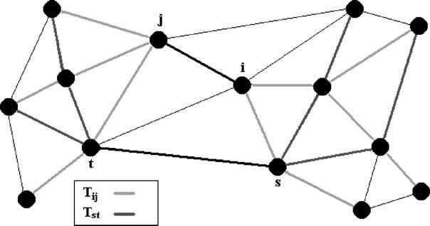

20

S. Taha, M. Kavehrad / Computer Communications 27 (2004) 13–26

EBR₂ј Expected Blocking Rate under 2nd CoS due to

the current virtual decision. Feed A₂and [W_{t}2 Q₁] into
Algorithm 1 to get EBR₂.
CBR₁ј Current Blocking Rate measured under 1st CoS.
CBR₂ј Current Blocking Rate measured under 2nd
CoS.
The algorithm can be explained as follows:
After every physical implementation of bandwidth
allocation, the algorithm waits for t_{r}seconds. This is to
wait for the transient response to approximately die. t_{r}can
be designed to be an adaptive parameter, but since we are
following the slow variations of demands, we can simply set
t_{r}based on the worst case scenario. As we explained earlier,
during a transient period, all incoming calls will be rejected
until the utilization drops below the new allocated
bandwidth. These rejected calls if accounted for, will feed
the algorithm with wrong information, which is why the
algorithm must wait until the transient period ends. The time
needed for the transient period to end can be approximately
estimated as in Eqs. (8) and (9).
Throughout every update interval t_{u}, information is
collected at each output port from the returning ACK
packets. For example, at output port l^{ij}; the algorithm
collects the rate of accepting and rejecting calls at each
output port related to T_{v}ij;v ј 1; 2: At the same time, the
algorithm collects all the VPCBRs declared at all output
ports related to T_{v}ij;v ј 1; 2: During the ﬁrst m updates, the
algorithm considers only information collected from all
output ports related to R^{ij}v;v ј 1; 2: Here, the algorithm does
not look at output ports related to B^{ij}v;v ј 1; 2; it is clear
that, if the algorithm does look at both the roots and
branches of the tree T_{v}ij at the same time, oscillation in the
decisions can occur. The idea of looking only at the roots of
the tree during the ﬁrst m updates can be interpreted as
providing a chance for the new demands to ‘dig’ through the
network. This is why we required the satisfaction of the
condition m $ (maximum number of hops), so information
about new demands originating at the UpLinks will have a
chance to reach the most-distanced possible DownLinks.
At clock ј xt_{u}, where x # m, algorithm computes the
expected demand on both CoSs by simply multiplying the
total arrival rate (both accepted and rejected calls) and
the end-to-end blocking probability for r_{v}ij;n;n ј 1; 2; …; s^{ij}v;
v ј 1; 2; then adding the results (Eq. (20)). Note that, the
total arrival rate for a speciﬁc ﬂow is the same at all output
ports visited by this ﬂow.
At each output port related to any r^{ij}v;n;the expected
blocking rate is computed based on the measured blocking
rate up to clock ј (x)(t_{u}) and the declared VPCBR at that
output port at clock ј (x 2 1)t_{u}(Eq. (21)). Note that, in Eq.
(21) the expected blocking rate at a speciﬁc output port is
considered to be the VPCBR itself if the measured blocking
rate were zero. The expected demand is then used to compute
a new virtual bandwidth allocation Q₁, based on the desired
objective function. Then, this new virtual allocation will
be used to compute and declare the new VPCBR at

Fig. 2. A schematic view of a network that shows two trees only.
clock ј (x)(t_{u}) at l^{ij}: The word ‘declare’ means that if any
signaling packet moves through l^{ij}after clock ј xt_{u}, it will
carry this new VPCBR to other output ports.
For clock . (m)(t_{u}), the ﬁnalization stage starts. A
serious problem must be faced in this stage, that is, which
output ports will implement their ﬁnal decisions ﬁrst and in
what order? By looking at the simple case shown in Fig. 2,
one can recognize the dependency that all output ports’
decisions have on each other. After careful study and
intensive simulations, we reach the following protocols that
need to be followed in the ﬁnal stage.
Once the mth decision is declared, all DownLinks declare
their semi-ﬁnal-1 decisions, which are basically the mth
decisions themselves at these DownLinks. The semi-ﬁnal-1
decision is computed in a similar way to the decisions that
are made during the ﬁrst m updates, with a major difference
that, at l^{ij}; only output ports related to B^{ij}v;v ј 1; 2; are
considered in the computations. So, in the semi-ﬁnal-1
decision, the algorithm looks at output ports after l^{ij}: This is
why, at a DownLink, the semi-ﬁnal-1 decision is the same as
the last regular decision, since there are no output ports after
a DownLink. In general, any output port l^{ij}needs to wait
until the ﬁrst output port of every b^{ij}v;n;n ј 1; 2; …; s^{ij}v ; v ј
1; 2; declares its semi-ﬁnal-1 VPCBR. Note that, when an
output port computes the semi-ﬁnal-1 VPCBR, the VPCBRs
collected from B^{ij}v;v ј 1; 2; are the semi-ﬁnal-1 VPCBRs.
The declaration of semi-ﬁnal-1 decisions may be viewed as
if there is a decision wave propagating from downstream
nodes to upstream nodes, we call this wave a semi-ﬁnal-1
decision wave.
Once a DownLink (say l^{ij}) declares its semi-ﬁnal-1
VPCBR, it waits for T_{pr}seconds (propagation time), which
is the required/expected time for the semi-ﬁnal-1 decision
wave to reach all the UpLinks. This time depends on the
maximum number of hops and on the signaling rate
throughout the backbone network, which can be easily
estimated. So, after t_{pr}seconds, all DownLinks compute and
declare the semi-ﬁnal-2 decisions which are computed
similarly to the semi-ﬁnal-1 decisions with a major
difference that, at l^{ij}; all output ports related to T_{v}ij;v ј
1; 2; are considered in the computations. In general, any
output port l^{ij}needs to wait until the ﬁrst output port of every
b^{ij}v;n;n ј 1; 2; …; s^{ij}v ; v ј 1; 2; declares its semi-ﬁnal-2
VPCBR. Note that, when l^{ij}computes the semi-ﬁnal-2

S. Taha, M. Kavehrad / Computer Communications 27 (2004) 13–26

21

VPCBR, the VPCBRs collected from B^{ij}v , v ј 1; 2; are the
semi-ﬁnal-2 VPCBRs, while the VPCBRs collected from
R^{ij}v;v ј 1; 2; are the semi-ﬁnal-1 VPCBRs. The declaration
of semi-ﬁnal-2 decisions may be viewed as if there is a
decision wave propagating from downstream nodes to
upstream nodes, we call this the semi-ﬁnal-2 decision wave.
Once an UpLink (say l^{ij}) receives all semi-ﬁnal-2
VPCBRs from the ﬁrst output port of every b^{ij}v;n;
n ј 1; 2; …; s^{ij}v ; v ј 1; 2; it declares the ﬁnal decision. In
general, any output port l^{ij}needs to wait until the last output
port of every r^{ij}v;n;n ј 1; 2; …; s^{ij}v; v ј 1; 2; declares its ﬁnal
VPCBR. The ﬁnal VPCBRs are computed similarly to the
semi-ﬁnal-2 VPCBRs.
Note that, when l^{ij}computes the ﬁnal VPCBR, the
VPCBRs collected from B^{ij}v , v ј 1; 2; are the semi-ﬁnal-2
VPCBRs, while the VPCBRs collected from R^{ij}v;v ј 1; 2;
are the ﬁnal VPCBRs. The declaration of ﬁnal decisions
may be viewed as if there is a decision wave propagating
from upstream nodes to downstream nodes, we call this the
ﬁnal decision wave. At a synchronized instance, clock ј t_{d},
all output ports physically implement the ﬁnal decisions that
were computed through the ﬁnal decision wave. рt_{d}2 mt_{u}2
t_{r}Ю should be greater than 3t_{pr}to ensure that all output ports
compute the ﬁnal VPCBR.
So, the ﬁnalization stage is composed of three decision
waves, after pumping virtual demands through the network
for m update intervals, which is enough to ensure that the
effects of new demands can reach the most-distanced node
in the network. The ﬁrst decision wave (semi-ﬁnal-1) starts
to provide the output ports with information about how
downstream links responded to the offered virtual demands.
The second and third decision waves, (semi-ﬁnal-2) and
(ﬁnal), work as correction waves for some possible wrong
information that might be generated by the ﬁrst decision
wave, as we explain later.
One may argue that information is being distributed by
the signaling packets and not by independent ﬂooding
packets, and that may result in missing some information
about speciﬁc ﬂows if they are not active and do not have
signaling packets during a speciﬁc t_{u}interval. Actually, this
is what the VDD algorithm can perfectly overcome, since
the expected demand is computed based on measurements
of the average arrival rate of different ﬂows and based on
updated information about latest virtual decisions of all
related output ports. One can easily realize that, if a speciﬁc
ﬂow is not active or completely dead through a speciﬁc t_{u}
interval, then this means the contribution of this ﬂow to the
total expected demand is insigniﬁcant. Hence, even if the
algorithm did not receive updated information about this
path, the effect will be absolutely negligible.

5. Performance analysis

In this section, we present the results of testing the
performance of the VDD algorithm. We compare

the performance of the algorithm with a SD algorithm that
uses locally estimated demands. So, both VDD and SDD
algorithm utilize Algorithm 2. However, SD estimates
average arrival rate of both CoSs using local measurements,
while VDD utilizes signaling messages in a coordinated
mechanism to gain wider vision and higher accuracy in
estimating average arrival rate of both CoSs every decision
interval.

5.1. Simulation settings

Fig. 1 shows conﬁguration of the simulated network. The
sophisticated simulation tool (Bones Designer) was used to
build a two-class multi-node network. This network was
built to emulate a real backbone network. Each node
represents a router; each router is connected to a LAN—not
shown in the ﬁgure—via a GateWay. Each LAN generates a
stream of calls (sessions) based on a Poisson random
process. Trafﬁc generated at a speciﬁc LAN is distributed on
all possible destinations forming a group of ﬂows based on
ﬁxed routing (shortest path). The average arrival rate of
sessions under each ﬂow varies slowly, following a
sinusoidal shape with a period of 48 h. The phase of this
sinusoid is different from one ﬂow to another. Another
slower sinusoidal function with a period of 196 h was used
to classify sessions into 1st class and 2nd class under each
ﬂow at each LAN, such that the maximum of the sinusoid
corresponds to 10% of the sessions being 1st class and 90%
being 2nd class. At the minimum of sinusoid, the opposite
occurs. Thus, a non-stationary trafﬁc/demand is generated
for a period of 48 h.
Average arrival rate of different ﬂows was set to congest
the network, in order to test the performance of different
algorithms. The requested bandwidth was generated follow-
ing a Binomial distribution with b¹ј b²ј 1:0 Mbps. The
requested bandwidth was quantized with a step of 100 Kbps.
Minimum requested bandwidth was limited to 100 Kbps
and the maximum to 10 Mbps. Thus, M₁ј M₂ј 100.
Holding time was modeled as an exponential distribution
with S²1¹ј S²2¹ј 10 min. The links’ bandwidth, W_{t}ј 3.0
Gbps.
For the VDD algorithm, we used the following settings
t_{d}ј 20 min, t_{u}ј 2 min, t_{r}ј 4 min, t_{pr}ј 1 min, and
m ј 6. For the SD algorithm, the decision interval was set
to be equal to t_{d}, in order to make the comparison valid. The
SD algorithm counts the number of 1st and 2nd CoSs calls
arriving throughout the t_{d}interval, in order to estimate the
average arrival rate of both CoSs.
As we mentioned earlier, the goal of VDD algorithm is to
provide accurate predictions of demands of different CoSs.
It is up to the network designer to choose the objective
function to be optimized. For this investigation, we chose a
simple objective function to demonstrate how well the
algorithm can perform. So the VDD algorithm is not the
DBA itself, but rather, it is a tool to provide accurate

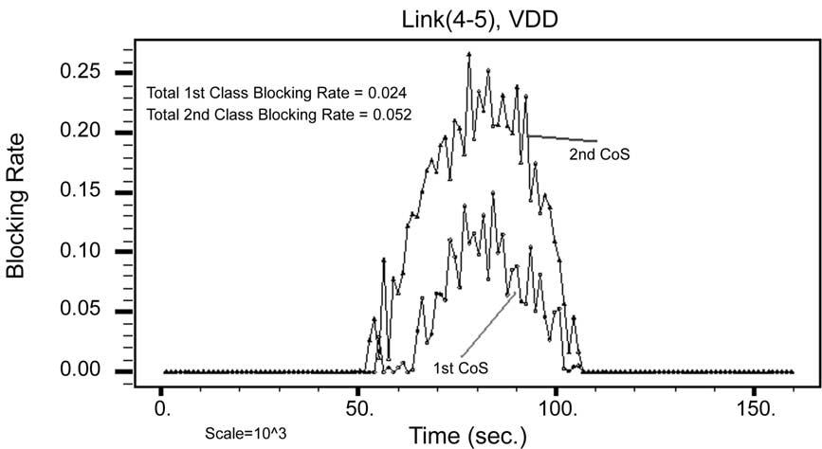
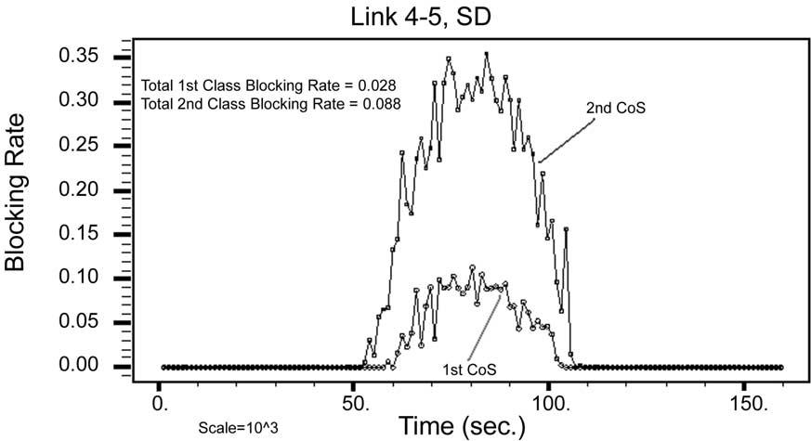

22

S. Taha, M. Kavehrad / Computer Communications 27 (2004) 13–26

Fig. 3. Blocking rates under the VDD at link 4-5.

prediction of demands that can be used by DBA algorithms.
In this simulation, we simply chose b ј 2.

5.2. Simulation results

Since our objective is to force the ratio of the 2nd class
blocking rate to the 1st class blocking rate to be two at any
output port (b ј 2), we selected l⁴⁵to be monitored, since it
is in the middle of the network. Fig. 3 shows the blocking
rate of both the 1st and 2nd CoS versus time at l⁴⁵for
the VDD algorithm, Fig. 4 shows the performance of SD
algorithm. It is clear that the VDD algorithm outperforms
the SD algorithm, proving the wider vision that VDD
enjoys. Fig. 4 shows the VDD approximately maintaining
b ј 2 almost all the time, while SD deviated from the value
b ј 2 most of the time. Fig. 5 shows utilization and
bandwidth allocation decisions for the VDD algorithm at
l⁴⁵, it can be noticed how the algorithm shapes the
utilization of both CoSs gradually to enforce the ratio b ј 2.
To clarify the importance of global vision, Fig. 6 shows
utilizations and bandwidth allocation decisions for the VDD

algorithm at l⁵⁷: It is interesting to compare this ﬁgure to
Fig. 7, which shows the equivalent performance of the SD
algorithm. Note, how the bandwidth allocation decisions in
the SD algorithm mistakenly congested the 2nd CoS during
a speciﬁc time interval while there are free resources
available, as can be noticed by comparing the 1st class
utilization to the allocated bandwidth for the 1st CoS. This
can happen simply because the SD algorithm cannot
estimate how many of the arriving calls are being accepted
by the DownLinks. However, the VDD algorithm is able to
evenly distribute the extra resources.
In another experiment, we broke link l⁵⁶at a speciﬁc
instance and intentionally increased the percentage of
1st class calls generated at node 1 and moved through l⁵⁶
to make the effect of breaking l⁵⁶more recognizable. Fig. 8
shows the performance of the VDD algorithm while Fig. 9
shows the performance of the SD algorithm. Again, we
can see how the SD algorithm failed to notice the effect of
breaking l⁵⁶; while the VDD algorithm perfectly estimated
the effect of this event and allocated resources,
accordingly.

Fig. 4. Blocking rates under the SD at link 4-5.

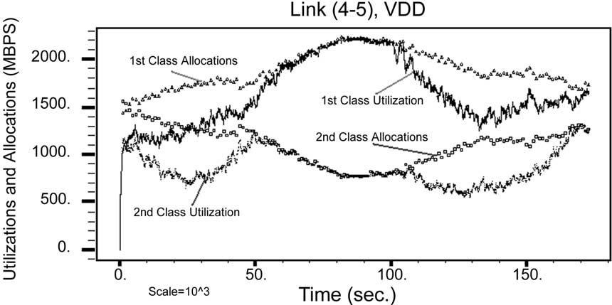
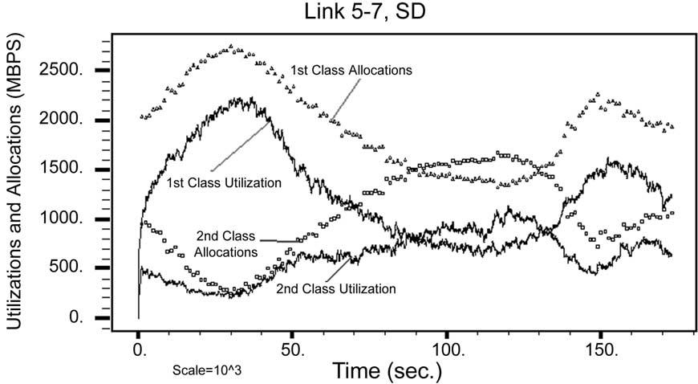
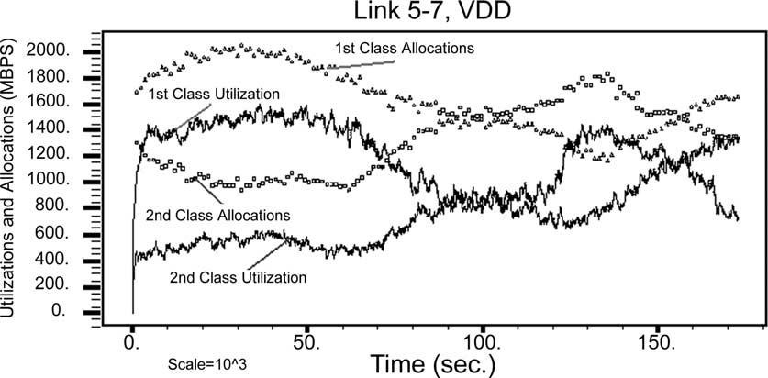

S. Taha, M. Kavehrad / Computer Communications 27 (2004) 13–26

Fig. 5. Utilizations and allocations under the VDD algorithm at link 4-5.

Fig. 6. Utilizations and allocations under the VDD algorithm at link 5-7.

23

5.3. Tradeoffs regarding the VDD algorithm

The most important feature of VDD algorithm is its
ability to have a wider vision when implementing a
bandwidth allocation decision. VDD algorithm does not
require extra signaling packets, which is a very desirable
criterion. It can be considered as a robust algorithm, since it
is not affected by failures in some parts of the network, and it

will always try to provide the best prediction of demands
based on the most recent available information. Dynamic
resource allocation based on prediction of demands has been
proposed in many previous works, the work in Ref. [11,12]
is an example of that.
As the Internet increasingly becomes the largest and the
most complicated machine in the world, and as the world
converges into one community, designing and policing

Fig. 7. Utilizations and allocations under the SD algorithm at link 5-7.

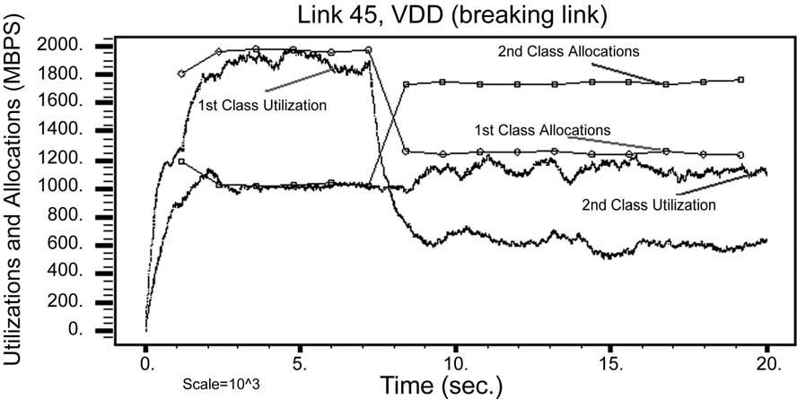
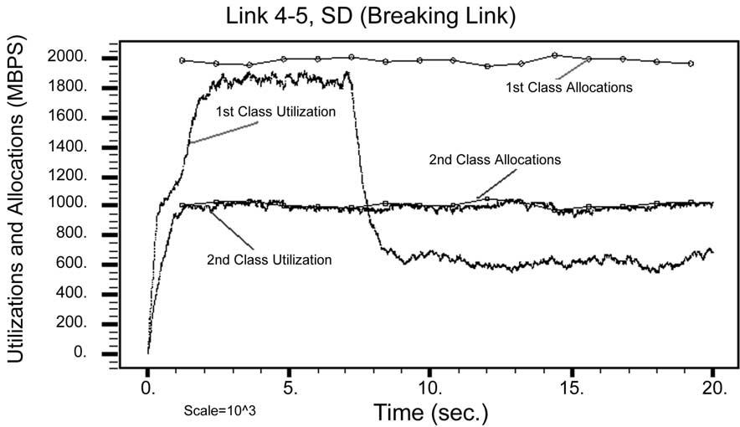

24

S. Taha, M. Kavehrad / Computer Communications 27 (2004) 13–26

Fig. 8. Performance of the VDD when link 5-6 was broken.

Fig. 9. Performance of the SD algorithm when link 5-6 was broken.

the network based on local geographical information will no
longer provide adequate results. The VDD algorithm
collects information about demands and congestion from
relevant ﬂows that can start and end at any location in the
world, thus avoiding this problem.
On the other hand, VDD algorithm adds more overhead
on the signaling packets and requires software upgrades at
all backbone routers where this algorithm would be
implemented. But this overhead is acceptable or even
lower than what was proposed in some previous works.
Like the frameworks proposed in Ref. [13,14], where
negotiation protocols with much more overhead than what
we proposed in this work were proposed. When the
network is underutilized, the VDD algorithm could be
considered as an over-engineered approach. The complex-
ity of optimizing an objective function may become high
if the network supports many CoSs, however, the
complexity involved in the mechanism of VDD would
not increase signiﬁcantly as the number of CoSs or VPs
increases.

6. Conclusion

The importance of accurate predictions of demands in a
multi-class multi-nodes connection-oriented network with
bandwidth segregation led us to develop a novel bandwidth
allocation algorithm, the VDD. Simulations showed that the
VDD outperforms an equivalent SD algorithm. Results
under non-stationary two-class trafﬁc with Poisson arrivals
in a multi-node network showed that VDD was able to near-
optimally allocate resources to the two CoSs based on the
selected objective function. Although we were not able to
mathematically prove that the VDD algorithm can produce
globally optimized decisions, we showed by network
analysis the existence of an algorithm that can issue globally
optimized decisions while operating in a distributed manner,
by collecting extra information about the network. Such
information still would be much less than the information
needed by a centralized algorithm. The potential of the VDD
algorithm to be used as a benchmark in large network
analysis increases its importance.

S. Taha, M. Kavehrad / Computer Communications 27 (2004) 13–26

25

Toward the development of the VDD algorithm, we

blocking a size-k call рB_{p}рb_{k}ЮЮ:

analyzed the prediction of call blocking rates in a single-link
X Y_{M}
n
j

adopting a CP scheme with two CoSs of non-stationary
trafﬁc, and developed a recursive algorithm to allocate
k[S_{k}
jј1^{r}j⁼n_{j}!
;

B_{p}рb_{k}Ю ј 1 2
X Y_{M}
n
j
рA3Ю

bandwidth between the two CoSs with the objective of
enforcing a speciﬁc ratio between the call blocking rates of
k[S
jј1^{r}j⁼n_{j}!

the two CoSs. This recursive algorithm considered
the blocking transient effects that may be experienced by
calls in a CP scheme. Then, the mathematical analysis was
extended to multi-class multi-node connection-oriented
networks adopting CP scheme under non-stationary trafﬁc
conditions. Then the VDD algorithm was motivated by this
loss networks analysis and evaluated by extensive
simulations.

Appendix A

In this appendix, we review previous work on predicting
call blocking rate experienced by calls with stationary
Poisson arrival process, stationary exponential holding time,
and variable-size requests with known distribution. Such
systems are known as stochastic Knapsack systems. We
show that the recursive algorithm (Algorithm 1), which is
detailed in Section 2.1, is the most suitable to our needs in
this research. The formulas and algorithms in this section
were derived in a clear way in Ref. [8].
Let the requested bandwidth be a positive real value (b)
with a density function f_{b}рbЮ; B_{p}: blocking probability, l:
mean arrival rate, m: mean service rate, and W_{t}: total
capacity. A closed form formula for B_{p}was found when
f_{b}рbЮ is uniform and 0 # b # W_{t}. The probability of
blocking a request of size b is:
where S_{k}ј {k [ S : kb·k # W_{t}2 b_{k}} and S ј {k [ I^{M}:
b·k k # W_{t}}: I is the set of non-negative integers. So, we
can write:
X
B_{p}ј P_{b}рb_{k}ЮB_{p}рb_{k}Ю: рA4Ю
kј1
The expression in Eq. (A3) cannot be computed easily
for reasonable values of M and W_{t}. A recursive algorithm
exits to compute the expression in Eq. (A3). It was shown in
Ref. [8] that this recursive algorithm works well for large
values of M and W_{t}. This is important, because in a real
backbone we expect large values of W_{t}for sure. This
recursive algorithm is detailed in Section 2.1. The formula
in Eq. (A3) gives an exact answer for the blocking rates for
very reasonable model assumptions that suite very well the
problem under study in this work. Thus, the recursive
algorithm that solves this formula was selected to be a
building block in the novel algorithm (VDD) proposed in
this paper.
One more technique that needs to be explored is the
asymptotic approximation. This approximation becomes
more accurate as W_{t}increases, which is a desired
behavior in our analysis. However, unfortunately, it
seems no closed form formula can be derived from this
approximation. The following equations constitute the
approximation:
d

B_{p}рbЮ ј 1 2
J₀р2^{p}ﬃﬃﬃﬃﬃﬃﬃﬃﬃﬃﬃﬃﬃﬃﬃﬃﬃ_{r}t²b_{t}Ю
J₀р2^{p}ﬃ_{Ю}
р
A1Ю
B_{p}рb_{k}Ю ј b_{k}
W_{t}
;
рA5Ю

where r ј l=m; J₀(·) is the modiﬁed Bessel function of order
0. Thus, we can write:

1 р^{W}t

d ј

s
2рa=sЮ
e 2s²
рa=s
2x²
e 2s²dx
21

;

рA6Ю

B_{p}ј
W_{t}
0
B_{p}рbЮdb:
рA2Ю
X
s²ј^{k}ј1
b²k^{r}k

;

рA7Ю

The problem in Eq. (A1) is the assumption that f_{b}рbЮ is
uniform over 0 # b # W_{t}. In any real network, usually the
maximum possible value for b is a small fraction of W_{t}. In
addition, the distribution of requested bandwidth is far from
W_{t}

X

b_{k}r_{k}

a ј^{p}ﬃﬃﬃﬃ_{W}t²kј1
ﬃﬃﬃﬃ

uniform.
The other alternative is to consider a limited number of
p :
t
рA8Ю

bandwidth sizes, such that a size-k session requests b_{k}units
of bandwidth with a probability of P_{b}рb_{k}Ю: In the context of
our analysis, we have l_{k}ј lP_{b}рb_{k}Ю and m_{k}ј m; ;k: Let
k ј Ѕb₁b₂…b_{M}; k ј Ѕn₁n₂…n_{M}; where n_{i}is the number of
size-i active calls in the link. An exact expression was
found, not closed form though, for the probability of
Another problem in this approximation is that it gives
accurate results as long as lal # 1.0. If this approximation is
to be used in a practical situation, lal can reach high values,
especially when the demand is higher than total serving
power. Our simulations showed that the approximation is
inaccurate, at all, for large values of lal.

26

S. Taha, M. Kavehrad / Computer Communications 27 (2004) 13–26

As we can see, a closed-form formula that can provide us The state/information at an output port is a general term

with the expected blocking rate in the case of variable size
bandwidth requests is not available, neither in an exact nor
in an approximate form. Thus, based on the above review of
previous work, it is clear that the recursive algorithm,
Algorithm 1 in Section 2.1, is the best approach to build
upon, in order to ﬁnd an approach for bandwidth allocation
between CoSs with the objective of forcing speciﬁc
differentiation ratios between the call blocking rates of
these different CoSs.

Appendix B

Proof of Claim 1 (stated in Section 2). In the following we
mean by an output port related to a tree that there is a ﬂow
member of this tree such that this output port is a member of
this ﬂow, by a decision a bandwidth allocation decision.
Consider any output port l^{ij}in a connection-oriented
network that supports two CoSs.

(1) Let l^{st}be any output port such that l^{st}– l^{ij}where
s; t; i; j [ N, s – t; i – j:
(2) Assume there is at least one f_{v}ij;k[T_{v}ij such that l^{st}[
f_{v}ij;k:Then, the effect that T^{r}рT_{v}st_{Ю}may have on the
decision at l^{ij}is implied in the state/information at l^{st};
where r ј 0; 1; 2; …; 1:
(3) If there is no f_{v}ij;k[T_{v}ij such that l^{st}[ f_{v}ij;k;then state/
information at l^{st}either has no effect on the decision at
l^{ij}or have an indirect effect if and only if there exists a
T^{r}рTv^{ij}Ю such that there exists a tree [ T^{r}рTv^{ij}Ю such that
l^{st}is related to this tree, where r ј 1; 2; …; 1: Note r
starts from 1 and not from 0.
(4) For the state/allocation at l^{st}to have no effect on the
decision at l^{ij}then ;v, v ј 1; 2; ;r; r ј 0; 1; 2; …; 1;
there is no T^{r}рT_{v}ij_{Ю}such that l^{st}is related to any tree
[ T^{r}рT_{v}ij_{Ю}: This scenario is shown in Fig. 2.
(5) So, there should exist an algorithm that only needs
to know aрf_{v}ij;n^{Ю};f_{v}ij;n [ T_{v}ij;;n; n ј 1; 2; …; s^{ij}v; ;v;
v ј 1; 2 and the state/information at each output port
(say l^{xy}) related to any ﬂow [ рT₁ij_{or}T₂ij_{Ю}; in order to
issue an optimal decision at l^{ij}: Note that, the state/
information at each output port l^{xy}is in itself a function
of all f_{v}xy;n[T_{v}xy and state/information at each port
related to any ﬂow [ рT₁xy_{or}T₂xy_{Ю}. A
that, in the worst case, can be an information package
containing the demands of all ﬂows composing the tree at
that output port. Note that, when the state/information at an
output port is designed for the worst case, we are actually
implementing a centralized algorithm with one improve-
ment, that demands on irrelevant ﬂows are not considered
by the algorithm. In the best case, state/information can be
brief information about some parameters of interest like
utilization and blocking rates of the two CoSs. Worst case
and best case here are in terms of complexity.

References

[1] J. Chan, D. Tsang, Comparison of static and dynamic bandwidth
allocation schemes for multiple QoS classes in ATM network,
Singapore ICCS ’94 Proceedings 2 (1994) 732 – 782.
[2] A. Maunder, P. Min, Dynamic bandwidth allocation to virtual paths
IPCCC ’98 IEEE International (1998) 94 – 100.
[3] E. Rosen, A. Viswanathan, R. Callon, Multi-protocol label switching
architecture, IETF (2001) RFC 3031.
[4] K. Kar, M. Kodialam, T.V. Lakshman, Minimum interference routing
of bandwidth guaranteed tunnels with MPLS trafﬁc engineering
applications, IEEE JSAC (2000) 2566 – 2579.
[5] E. Dinan, D.O. Awduche, B. Jabbari, Analytical framework for
dynamic trafﬁc partitioning in MPLS networks, ICC 2000 3 (2000)
1604 – 1608.
[6] R. Cue’rin, H. Ahmadi, M. Naghshineh, Equivalent capacity and its
application to bandwidth allocation in high-speed networks, IEEE
JSAC 9 (7) (1991) 968 – 981.
[7] I.C. Paschalidis, J.N. Tsitsiklis, Congestion-dependent pricing of
network services, IEEE/ACM Transactions on Networking 8 (2)
(2000) 171 – 184.
[8] K.W. Ross, Multiservice Loss Models for Broadband Telecommuni-
cation Networks, Springer, London, 1995.
[9] A. Odlyzko, The economics of the internet: utility, utilization, pricing,
and quality of service, AT&T Labs-Research (1998).
[10] W. Stallings, Data and Computer Communications, Fifth ed.,
Prentice-Hall, Englewood Cliffs, NJ, 1997.
[11] S. Gupta, S. Bose, R. Harris, L. Berry, Distributed dynamic bandwidth
allocation and management for self-healing broadband networks with
multi-class trafﬁc, IEEE GLOBECOM’98 2 (1998) 1166 – 1171.
[12] H. Saito, Trials of dynamic bandwidth allocation in ATM networks,
Proceedings of IEEE ATM Workshop, 1997, pp. 141 – 146.
[13] E.W. Fulp, D.S. Reeves, On-line dynamic bandwidth allocation,
Proceedings of the International Conference on Network Protocols,
1997, pp. 143 – 141.
[14] S. Jordan, H. Jiang, Connection establishment in high-speed networks,
IEEE JSAC 13 (7) (1995) 1150 – 1161.

